Many Reasons to Celebrate at May 20 Assembly in Crawfordsville
Hosted by Wabash Avenue Presbyterian Church in Crawfordsville who are celebrating 190 years of ministry and surrounded by the richly patterned colors and symbols of its sun-drenched stained glass, more than 110 of us gathered as Presbytery to worship, work and share fellowship. The Assembly:
- Celebrated in community with Synod Executive Carol McDonald her nearly three decades of service in ministry to our Presbytery and
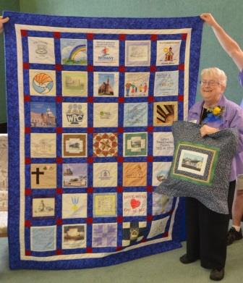
Rev. Carol McDonald
(Photo courtesy of Rev. Chuck Compton)
- Synod, as well as General Assembly. Terri Thorn, Diane Shircliff and Gladys Sargent delivered greetings by song, as well as a beautiful quilt incorporating panels provided by numerous congregations of PWV. Ruby Kleymann served on the hospitality team & quilted the pillow. Wabash Avenue members provided beautiful buffets of welcome, lunch and reception in honor of Carol.
- Focused on this month's Habakkuk scripture passage inviting reflection and shared thoughts on asking, questioning, waiting, and discerning God's response to us.
- Worshipped together led by Rev. John Van Nuys (Wabash Avenue), Nancy Brinklow (La Porte), and Carol McDonald (Synod Executive) who preached from Jeremiah 29 and Romans 8, noting "Interrupted Correspondence..." that continues to speak to the Church today. In worship, Moderator Jeff Cover commissioned the presbytery commissioners to the 221st General Assembly that meets in June and the Assembly sang with open hearts and strong voices to the virtuosic accompaniment of John Blair. $465.66 was received in support of the Pentecost Offering to benefit children and youth ministries.
- Examined and approved Candidate Harry A. Roselle, Jr. (from Hudson River Presbytery) presented by CPM and COM for ordination to the call issued by Deer Creek Presbyterian Church.
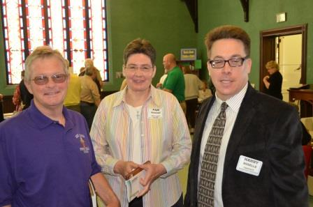
Mike Munson, Pam Winings Deer Creek PC & Candidate Harry Roselle, Jr.
(Photo courtesy of Rev. Chuck Compton)
- Received and reviewed current financial reports for Presbytery and Geneva Center, noting deficits. The end of presbytery's third fiscal quarter shows a surprising $94,000 deficit. Budgets are built upon per capita expectations, and per capita numbers result from the annual session statistical reports that update actual membership. Six congregations who historically remit their per capita contributions have not done so currently, leading to the unexpected shortfall; expenses are within budget expectations. Geneva Center finances, while showing a deficit, are closer to budget. Assembly approved a six-month budget without major changes as recommended by Stewardship Ministry Team and Council to allow time to review and take action upon recommendations yet to proceed from the Joshua Journey process concerning Presbytery priorities: Geneva Center as presbytery mission, and structure and staffing. If previous levels of per capita support are paid as expected, the budget will be balanced; if the current pattern continues, there is likely to be another $32,000 deficit. Current reserves are sufficient, but General Presbyter Frank Vardeman reminded the Assembly that it is crucial that PWV return to balanced budgets.
- Elected Sandy Carlson (RE First, Michigan City) as 2014 moderator of Personnel Committee and Robert Shaw (TE, Christ, Winfield) as 2014 vice moderator of COM.
- Celebrated the work of the Administrative Commission (AC) for Rensselaer and dismissed them with thanks; charged ACs to walk with First, Plymouth and Thorntown Presbyterian Church as each session discerns possibilities for their ministries, and to prepare to close them if necessary; charged an AC to negotiate proposed settlement with Church of the Good Shepherd concerning litigation it filed, and its possible dismissal to the EPC; and thanked and dismissed the Listening Team for Calvary, Logansport.
- Received gifts of calligraphy tapestry for Wabash Avenue
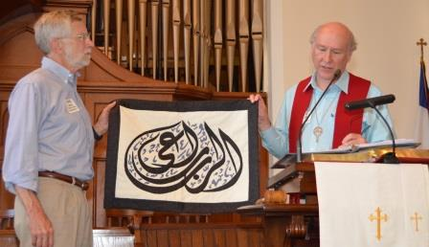
David Hadley, Wabash Ave. PC Accepting Tapestry from Rev. Jeff Cover, PWV Moderator
(Photo courtesy of Rev. Chuck Compton)
- congregation and the Presbytery from Joshua and Rebecca, with gratitude for donation of the extensive library of Wabash Avenue member and theologian William Placher to the Christian seminary and for the mission partnership with presbytery congregations. Assembly also watched the video update from our mission co-workers. (Please contact Vicki at 574-223-5678 or vicki@ourpresbytery.org to request a copy of the video on CD.)
- Listened to explanation of Board of Pensions changes coming in 2015, invitations to join Geneva Center Summer Camp as shepherds and volunteers as well as sponsors for campers, and timetable of Joshua Journey Team 2 to make its recommendations to September Assembly.
- Prayed for joys and concerns expressed during the day, and adjourned early to move to reception for Carol McDonald in the Fellowship Hall.
- Linda Long, Stated Clerk

